Educational Assignment Dashboard
Group - D
Debaleena Talukdar, Soumalya Pakrashi, Vaishali Mondal

Software Requirements Specification

Document

Version: (1.0) Date: (07/18/2021)

Table of Contents

1. Introduction
1.1 Purpose
1.2 Scope
1.3 Definitions, Acronyms, and Abbreviations 5
1.4 References
1.5 Overview

2. The Overall Description
2.1 Product Perspective
2.1.1 System Interfaces
2.1.2 Interfaces
2.1.3 Hardware Interfaces
2.1.4 Software Interfaces
2.1.5 Communications Interfaces
2.1.6 Memory Constraints
2.1.7 Operations
2.1.8 Site Adaptation Requirements
2.2 Product Functions
2.3 User Characteristics
2.4 Constraints
2.5 Assumptions and Dependencies
2.6 Apportioning of Requirements

3. Specific Requirements
3.1 External interfaces
3.2 Functions
3.3 Performance Requirements
3.4 Logical Database Requirements
3.5 Design Constraints
3.5.1 Standards Compliance
3.6 Software System Attributes
3.6.1 Reliability
3.6.2 Availability
3.6.3 Security
3.6.4 Maintainability
3.6.5 Portability

4. Change Management Process 14

5. Document Approvals 14

6. Supporting Information 14

1. Introduction

1.1 Purpose

This SRS Document is used to highlight the functionalities of an application implementing an Educational Assignment Dashboard. It also includes various other aspects of the application which includes avenues like performance, security, privacy, etc.

This document is intended towards the customers of this project, any interested stakeholders, the designers, developers, the testing team, and the operations team. This document also appeals any documentation writers, marketing and management personnel and other such people associated with this project.

1.2 Scope

This SRS Document entails the following features:

1.2.1. This project is named “Educational Asignment Dashboard”.
1.2.2. This project will create an online interactive platform for teachers, studnets, as well as administrators to perform various predefined academic activities and track the workflow of the involved users.
1.2.3. This software is not concerned with any administrative workflows not pertaining to academic activities.
1.2.4. Any organization willing to establish an online educational system will be benefitted from using this software.

1.3 Definitions, Acronyms, and Abbreviations.

1.3.1. Operations Team: The team which takes care of coordinating and deploying the software.
1.3.2. SRS: Software Requirements Specification
1.3.3. External IO: The data that is received by the system as input or sent by the system as output from/to an external system. It is assumed that this software is interfaced with the external system.
1.3.4. IOT: Internet of Things
1.3.5. Raspberry Pi Zero: A popular IOT device.
1.3.6. Cloud Native Application: Applications which are designed to leverage the full potential of Cloud infrastructure.
1.3.7. Container: It is an isolated and independent space which hosts applications along with any dependencies and binaries that the application may need.
1.3.8. Distributed Version Control System: A software spread across multiple machines which can track changes (and thus different versions) of any document.
1.3.9. Git: A popular distributed version control system.
1.3.10. GitHub: An online platform for storing documents (commonly used for storing source code) and which integrates very well with Git.
1.3.11. API: Application Programming Interface.

1.4 References .

The following resources have been referenced while developing this software:

1.4.1 Google Classroom
1.4.2 Microsoft Teams
1.4.3 Git
1.4.4 GitHub
1.4.5 Raspberry Pi Zero

1.5 Overview

This SRS Document is organized in different sections. Section 2 describes every feature of the system in common language and is suitable for a customer or a sales manager. Section 3 describes the system in greater detail from an implementation point of view and is suitable for designers and developers.

Overall, the system can be visualized with an Use Case Diagram as follows:

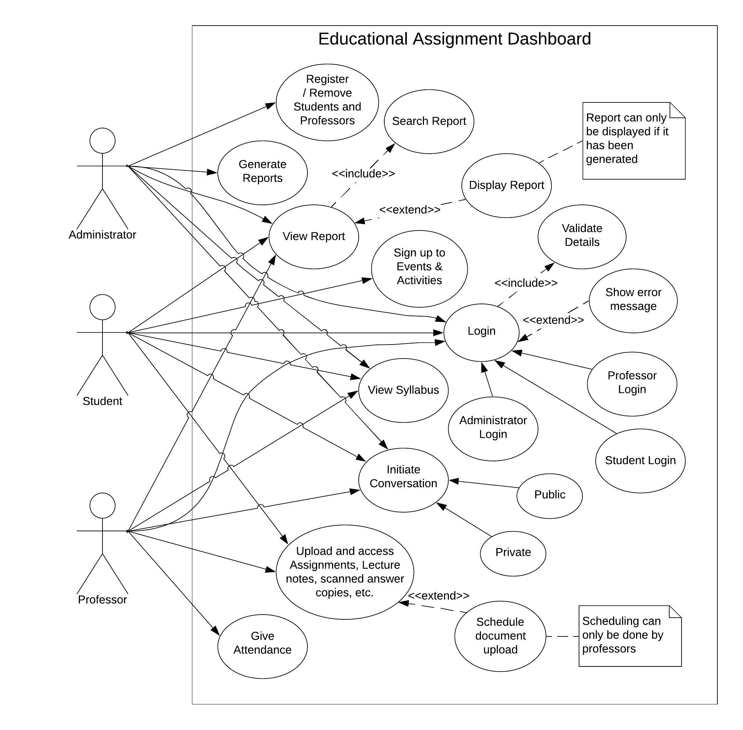

2. The Overall Description

This product, named “Educational Assignment Dashboard”, is an interactive online platform for carrying out academic activities in a typical school, college, or university. The following subsections define the product in further detail in such a way which is understandable to a common user.

2.1 Product Perspective

This product can be related to popular products in the market like Google Classroom and Microsoft Teams. It is assumed that this project is not self-contained and is part of a larger ‘Institution Management System’ which does most of the administrative heavy-lifting. The ‘Institution Management System’ is expected to be in charge of carrying out most of the administrative workflows of the institution which includes, but is not limited to student enrolments, professor or administrator onboarding and leave, management of financial activities, management of accounts, etc. It is assumed that the data required for carrying out the above activities are already stored and managed by the above mentioned system. Our system, “Educational Assignment Dashboard”, will retrieve necessary data about students, faculty, and staff and write back data regarding the final gradation of students in the system. Everything else is managed entirely in the system and does not require any interference from any outside system. Our project in respect to the bigger system can be visualized in a very basic sense as follows:

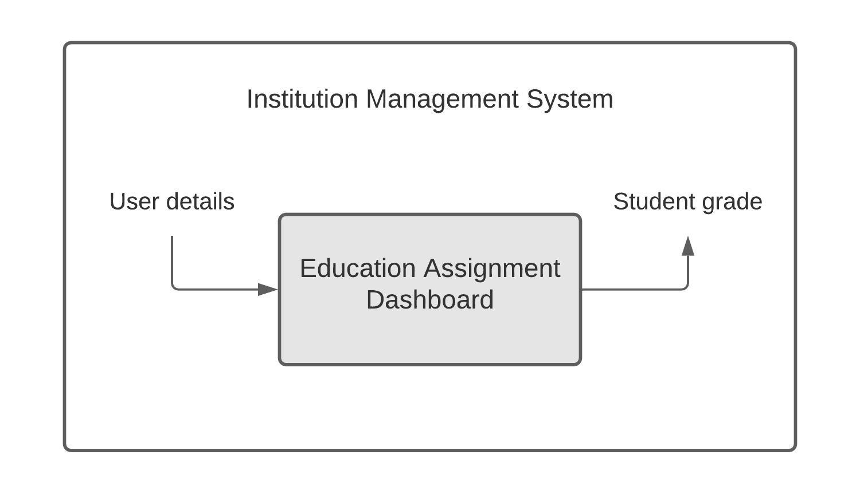

Although this system works similarly like Google Classroom and Microsoft Teams, there are some key differences. The major difference is that this system tightly integrates with an existing ‘Institution Management System’ and thus, the entire process of administration and management becomes simplified and most of the work can be automated.

2.1.1 System Interfaces

This ‘Educational Assignment Dashboard’ interfaces with an ‘Institution Management System’. The latter system is expected to be having an internal API for communicating and interfacing with the same. This is used for the following purposes:

2.1.1.1. Obtain necessary personal information of students.
2.1.1.2. Obtain necessary personal information and achievements of professors.
2.1.1.3. Obtain necessary contact information of concerned admins.
2.1.1.4. Generate the grade of the students and transfer the same to ‘Institution Management System’ over the API.

2.1.2 Interfaces

This software product will have a web-based graphical user interface which can be accessed through a browser. Anyone with basic knowledge in using the web can use the application. It will also have a corresponding app for Android and iOS devices.

This software is designed in such a way that it is accessible to people with disabilities such as blindness.

2.1.3 Hardware Interfaces

The system has no hardware interface requirements.

2.1.4 Software Interfaces

The system must use ‘Institution Management System’ internal API v5.6 to communicate with the interfacing system. With the help of this API, this system will transfer the required data to perform its external IO operations.

2.1.5 Communications Interfaces

The system has no communications interface requirements.

2.1.6 Memory Constraints

The system has no memory constraint requirements.

2.1.7 Operations

This system does not have any special user operation requirements that is not under the control of the system.

2.1.8 Site Adaptation Requirements

As this software interfaces with the ‘Institution Management System’ and communicates over its API, prior to installation of this software, the ‘Institution Management System’ must be online and its respective API must be accessible.

2.2 Product Functions

Our system is expected to support the following functions:

2.2.1. The professors, students and administrators will be able to login to the system. All the group of users will be presented with a separate login proves as both of them have different roles in the system.
2.2.2. Professors can upload lecture notes, assignments, etc. In response, students can download the same and upload (scanned) answer copies.
2.2.3. Administrators should be able to add or remove students and professors to/form their respective online classes. Adminstrators should be able to initiate the process of report generation and also control when the student will be able to view them.
2.2.4. Studnets should bot able to sign up for the classroom by themselves.
2.2.5. Marks for each student should be maintained properly.
2.2.6. All the groups of users should be able to communicate in the classroom with each other both publicly and privately.
2.2.7. The detaild sullabus of the curriculum should be accessible to everyone.
2.2.8. The attendance will be updated by the concerned professor and will be managed by the system.

2.3 User Characteristics

In our system, we have 3 groups of users – Administrators, Professors and Students.

The Administrators in our system are expected to have sufficient knowledge and basic technical expertise to handle the management related works in our project. The Professors are expected to be efficient in their field of work. The teachers are not expected to have good technical skills. The Students in our system are from varied educational backgrounds ranging from junior schools to universities. They may or may not have proper technical skills.

2.4 Constraints

Our system is expected to have the following constraints:

2.4.1. All functions of the system should be equally accessible from computers, mobiles and tablet devices.
2.4.2. Each student should be able to see their own corresponding progress and the details of the teachers teaching them.
2.4.3. Each teacher can have an overview of the progress of the class and can also schedule various document submissions in the classroom. They should also be able to see various personal information of the students.
2.4.4. Our system should be reliable as it is dealing with academic content which needs to be maintained accurately.
2.4.5. This system should be able to scale up and down whenever required (especially during exam and report generation time when there is a huge load on the server).

2.5 Assumptions and Dependencies

Some assumptions made for the proper functioning of the system are as follows:

2.5.1. The users of this system are using atleast a standard and decent computer (or mobile device) and not some IOT devices like Raspberry Pi Zero. Althugh it will totally work in that system, the performance can be degraded.
2.5.2. A working internet connection is required for uploading and downloading content and performing various other activities.

Some dependencies of the system are as follows:

2.5.3. It depends on the API provided by the ‘Institution Management System’ for interfacing with the latter. So, the larger system must be online and the API should be accessible for our system to work properly.
2.5.4. The web version of the software needs a working internet connection all the time. In the app version for mobile devices, it will work for certain features like viewing download content, but for all the features, and internet connection is required.

2.6 Apportioning of Requirements.

The following requirements can be delayed to a later release of the product:

2.6.1. The software in its current iteration, only assists people with blindness as a disability. But in the future, it will support more groups of people with disabilities like paralysis and those who cannot use traditional interactive devices like mouse and keyboard, this will be done with a voice-assistant feature integrated in the system with which all the functions of the system can be performed.
2.6.2. The app will be able to perform wide variety of functons like uploading of assignments, sending amessages to users and such even in offline mode. All the functions which require an internet connection to complete, will be queued and will automatically be performed in the background, the next time when internet connection becomes available.

3. Specific Requirements

3.1 External Interfaces

The following external interfaces to our system are recognized:

3.1.1. Student Info: Student information which includes student ID, registration number, roll number, name, picture, batch, stream, contact information and email ID are taken as input from ‘Institute Management System’ using the internal API.
3.1.2. Professor Info: Professor information which includes professor ID, name, picture, stream, designation, achievements, contact information and email ID are taken as input.
3.1.3. Administrator Info: Information about administrators which includes admin ID, name and position (or role), contact information and email ID are taken as input.
3.1.4. Student Grade: The final grade of a student at the end of a session are output to the ‘Institution Management System’ using the same API.

3.2 Functions

The functions which should be supported by the system are as follows:

3.2.1 Professors should be able to upload assignments, lecture notes, etc.
3.2.2 Students should be able to scan their copies and upload in the system.
3.2.3 The system should maintain the marks of each student properly.
3.2.4 Students should be able to see their progrees reports.
3.2.5 Administrators should be able to add/remove students and professors to/from their respective online classrooms.
3.2.6 Students should not be able to sign-up for the classrooms by themselves.
3.2.7 Students and teachers should be able to communicate with each other in the online classroom both publicly and privately.
3.2.8 Separate and independent online classrooms should be maintained for each batch of students (not for each semester).
3.2.9 Attendance record of each individual student must be maintained properly (only the total attendance needs to be maintained and not on a per day basis).
3.2.10 Both students and teachers should be able to access the detailed syllabus of the curriculum.
3.2.11 Administrators should be able to initiate the process of report generation and also control when the students will be able to view them.
3.2.12 Students, professors and administrators should be able to login to the system.

3.3 Performance Requirements

The following performance features can be observed:

3.3.1 Users should not have to wait for uploads to finish before continuing with other activities in the app. All uploads and downloads should happen in the background.
3.3.2 In peak workload conditions, software should not crash. If immediate service is not possible, it should show a helpful message to the user.
3.3.3 Even in peak working conditions like report release, students should not have to wait for more than 2 seconds to get their reports on their device.
3.3.4 Image formats including JPEG, PNG, WEBP and RAW should be supported.
3.3.5 Video file formats including MP4 and MOV should be supported.
3.3.6 All types of text based files should be supported.

3.4 Logical Database Requirements

The following logical database requirements are observed:

3.4.1 Students should not have access to their reports prior to the release even if the reports have been generated.
3.4.2 Administrators and teachers can have access to reports after generation even if it has not been released.
3.4.3 Adiminstrators can have access to all the classrooms in the system.
3.4.4 Teachers and students should not be able to access classrooms to which they have not been assigned.

3.5 Design Constraints

This system has no design constraints.

3.5.1 Standards Compliance

This system does not need to comply to any preset standards.

3.6 Software System Attributes

3.6.1 Reliability

The system should have provisions for caching failed transactions locally. For example, if the internet connectivity gets disrupted while uploading assignments or exam answer sheets, it should be cached locally and the time when it was submitted should also be recorded. The next time when the system comes online, the online transaction should be automatically done in the background.

3.6.2 Availability

The website will have to have a high availability, that is, it has to be accessible throughout the entire day. During peak times, like when reports are released, the system is expected to handle the spikes in usage efficiently.

The mobile application is not expected to have a high availability as the user will only be using the app when interacting with the class. This activity is only performed during certain times of the day.

Overall, as our system does not deal with much critical and realtime data, the availability of the system is not of great concern and minor downtimes will not affect the users to a great extent.

3.6.3 Security

As this software is not dealing with any high risk or personal information, it is not susceptible to much malicious access. Also, no user is given any permission to perform any critical tasks like deleting any data from the database. So, the scope of any accidental access is next to none.

3.6.4 Maintainability

As we are building a Cloud Native Application, the maintainability of this system is not of our concern. Although, periodic updates to remove bugs and improve the feature set of our system would be performed.

3.6.5 Portability

Our system is containerized and hosted on the cloud. For this reason, it has got no host-specific dependencies. At the same time, as containers are supported by almost all of the cloud providers, the system is not bound to any particular provider either. So, it is totally portable to any cloud provider.

For the mobile app, the system will be developed in the Flutter language which is cross-platform and a single code base will compile for both Android and iOS devices.

Change Management Process

The customer should send an email containing a detailed information about any changes or feature updates that need to be done to the system. Upon settling the new or modified requirements with the customer, a new version of this SRS Document shall be prepared and the different versions of this document shall be tracked by a Distributed Version Control System like Git.

The entire system will be hosted as a private repository on GitHub. This will enable all the developers to not only work together on the same project, but also on different parts of the project. Upon finalizing this SRS Document, the new or updated feature will be assigned to the team leader of the respective department. From here, the team leader will distribute the work among the various concerned personnel in his/her team.

Document Approvals

  - Mr, A Gupta – Senior Project Manager (10-07-2021)
  - Ms. S Sengupta – Senior Documentation Analyst (10-07-2021)

Supporting Information

Index:

  - Operations team: Page 5
  - Educational Assignment Dashboard: Page 5
  - Institution Management System: Page 7
  - SRS: Page 5
  - External IO: Page 8
  - IOT: Page 10
  - Raspberry Pi Zero: Page 10
  - Cloud Native Application: Page 13
  - Container: Page 13
  - Distributed Version Control System: Page 15
  - Google Classroom: Page 6
  - Microsoft Teams: Page 6
  - API: Page 7
  - Android: Page 8
  - iOS: Page 8
  - Flutter: Page 13
  - Use Case Diagram: Page 5
  - Git: Page 15
  - GitHub: Page 15

